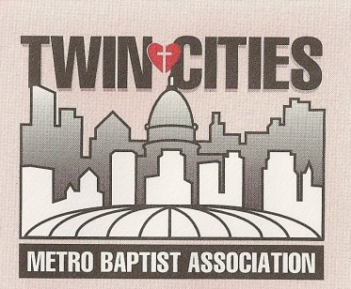
“A Great Commission Association”
Block Party Trailer Protocols

I. TRANSPORTATION
A. Responsibility. The group scheduling use of the trailer assumes full responsibility for transportation of the trailer to/from the stored location or another location as indicated by the schedule. If it has been at another church location make arrangements to pick up the trailer from the previous user.
B. Transportation Time. The trailer must be delivered to the next church in time for them to use it or two (2) days following its use to a previously agreed upon site or as in agreement with the TCMBA office.
C. Inventory. A careful inventory of the equipment should always be made, before use and after use.
D. Type of Vehicle. A pickup truck is sufficient to transport trailer and accessories. The hitch requires a 2” ball and a flat four connector. The weight of the trailer is @3000 lbs.
E. Trailer Lights. Please make sure all trailer lights are working when transporting and when it is returned to the storage location.
F. Return of Trailer - If returning the trailer to the Southtown Baptist Church site, at 2600 W 82nd Street, Bloomington, MN, please back the trailer into the concrete parking pad next to the large tree in the northeast corner of the main parking lot. Attach the trailer to the pine tree with the cables which will be in the trailer. Do NOT park it on the grass!

II. INSURANCE
A. Adequate insurance coverage is required for your use of the block party trailer for your event. The TCMBA has coverage for the trailer. Please contact your insurance company for coverage on your vehicle.
B. Note: If the trailer is left unattended, it would be difficult to collect from the insurance company in case of theft or vandalism. Please use the cables, which are provided, to secure the trailer. You will need to get the combination from Steve to unlock the securing cables and trailer locks.
C. Please keep the proofs of insurance and license registration in the trailer at all times.
D. Collision Insurance: In most cases, your car’s liability insurance covers vehicles you are towing. We suggest you check with your agent to verify this.

III. PERMITS
Any civil or utility permits are the sole responsibility of the user of the trailer. Check with your local City Hall and Fire Department.
Block Party Trailer Protocols
IV. DAMAGES
Please tell us about any damages to the trailer while it is in your possession. We will then find the correct resources to fix the damages.

V. FEES
The application along with $150 will need to be turned in to the TCMBA office prior to use of the block party trailer. Please write out two checks, one for $100 and one for $50. There is a $50 refund if the block party trailer is returned to the TCMBA in the same condition it was received. The refund will not be returned if there is any additional clean up of the trailer or equipment is put away in the wrong place. In order to facilitate multiple requests for the same time period, the first application with the required checks will have priority. When the application and checks have been received a confirmation of the reservation will be sent. If the reservation is canceled and another church is then scheduled, the application checks will be returned.

VI. TRAINING
To help ensure that the Block Party Trailer is used to its greatest ability and to help ensure that the equipment is not damaged or injury occurs to those using the equipment, those desiring the use of the Block Party trailer must either attend a TCMBA training event or attend a block party where the trailer will be utilized. Contact Steve for future training events or block parties.

