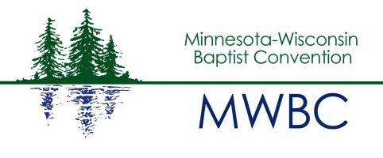
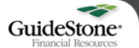

2016 Southern Baptist Convention Compensation Study
The 2016 Compensation Study was a joint project of state Baptist conventions, GuideStone Financial Resources, and LifeWay Christian Resources. Compensation and congregational data was collected anonymously from ministers and office/custodial personnel of Southern Baptist churches and church-type missions. Reports are based on compensation for over 14,000 respondents from 40 state conventions.
To access the survey, click on the following link:
http://compstudy.lifeway.com/homepage.do;jsessionid=017E123D7AC6B8D2B9022EF2FF231E9E

