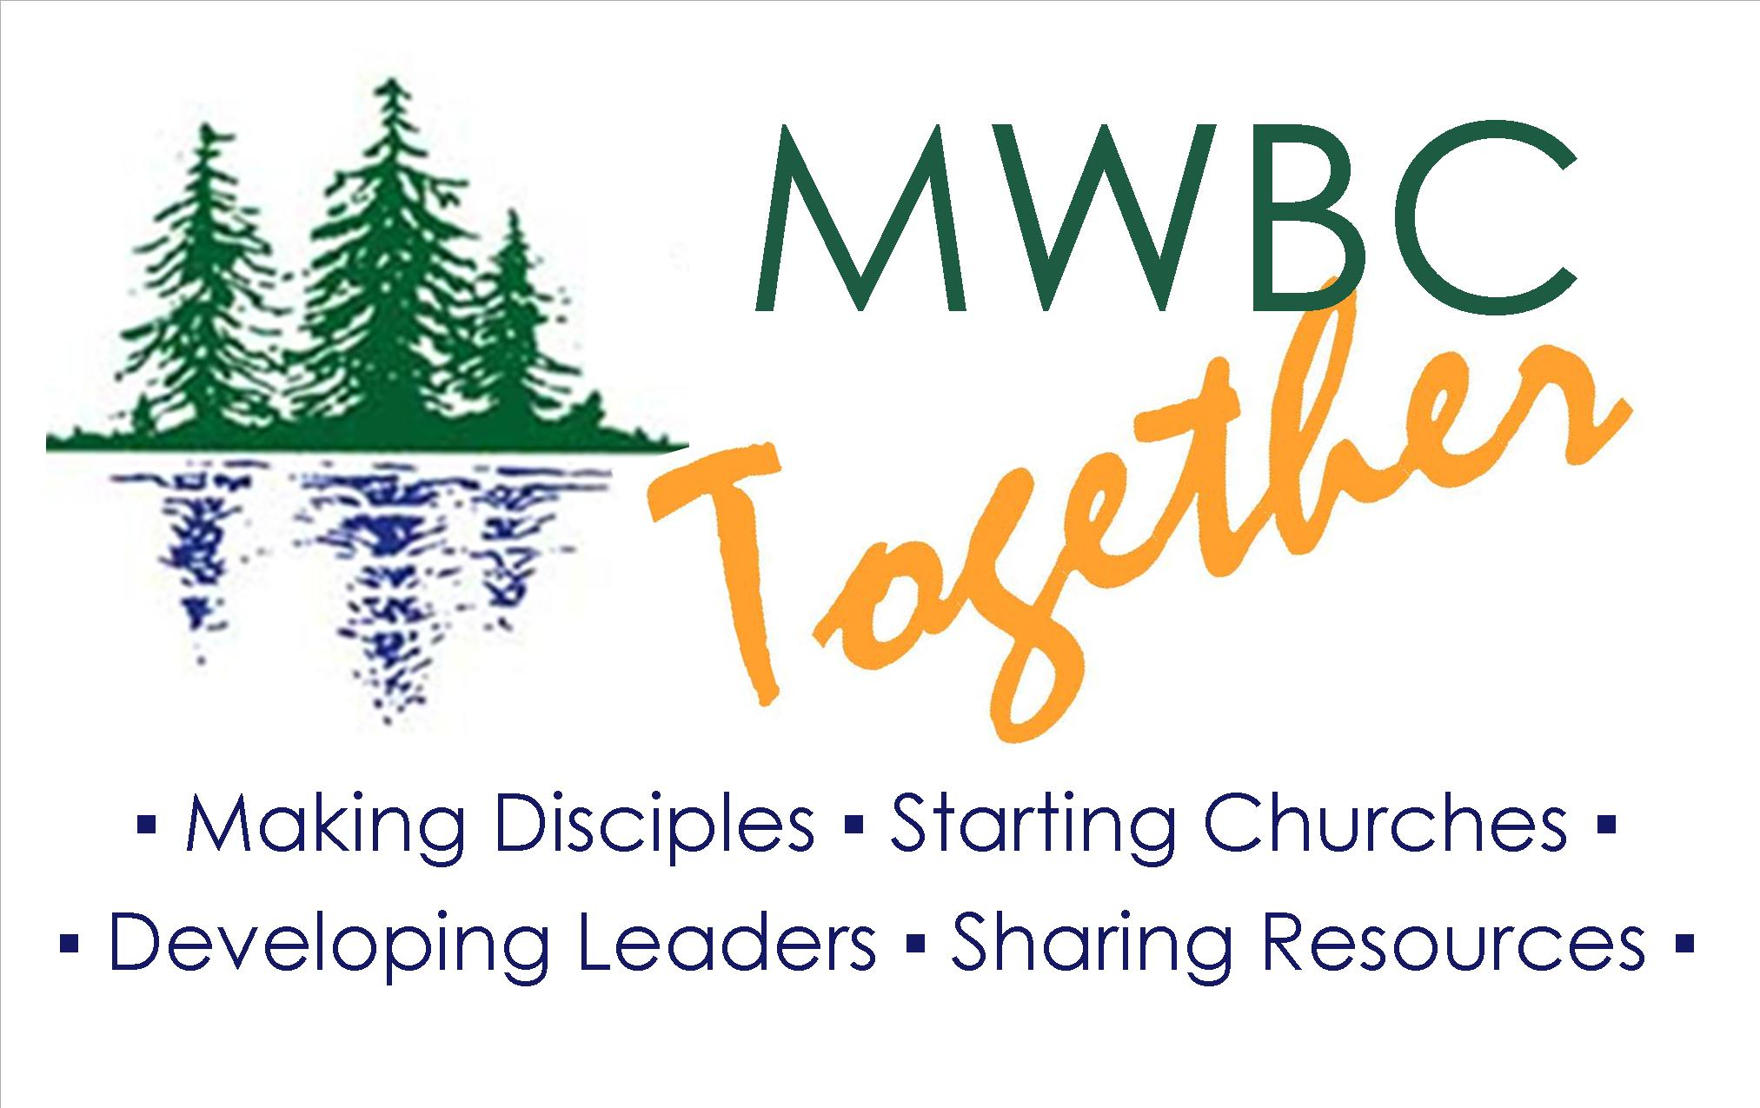

You may be eligible for the following benefits from the Minnesota-Wisconsin Baptist Convention and GuideStone:
• Disability income benefit (up to $500 per month).
• Survivor protection benefit (up to $100,000).
• Matching retirement contribution (up to $210 annually).
Enroll over the phone: 1-888-98-GUIDE (1-888-984-8433) Monday-Friday, 7 a. m. to 6 p.m. CST or go to the GuideStone Website at http://www.guidestone.org/SBCChurchBenefits.
A pastor of a Southern Baptist mission or church with annual church budget receipts less than $75,000 may be eligible to receive $3,000 in retirement contributions over 60 months. Call GuideStone for more information.

